

Case study: Digital expansion overseas

Submitted by

SHRUTI.

Branch: EXTC

Roll No.: J201

**Problem Statement**

An upcoming software development company in India wants to digitally expand its operations and services in UK and US region keeping the CAPEX as light as possible. Create marketing strategies for the same.

**Marketing Strategy**

Expansion of any firm revolves around performing a full market research and company analysis by evaluating the core, adjacent and the “white spaces” markets in the desired expansion region. Then, accurately measuring and assessing the services currently being offered by the firm. Evaluation of the new emerging markets and determining the product growth according to that.

Analyzing the core competitors and their products. The cost at which they are offering the services and the types of customers who are attracted towards them.

Many software companies collaborate with companies offering services like product managemen and strategy planning teams. These mergers are necessary for the company because it helps in their organic growth without the constrains of new technologies. They can thus easily adapt to the constantly changing markets due to the continuous evolution in software development.

1. **Market research**

The region the firm is planning to enter should be researched deeply to know whether the services offered for the software development in India is needed in US or UK or not. Competitor research is also important to know what all services the existing local companies are offering to which the customers are attracted to and what new we can offer to attract their customers to our side. The local competition knows the customers prior to us and thus they provide those services to the people but as a new entrant and an outsider to the region you have to start from scratch and can have new ideas from your past experiences from India and some of them could be applied there. we need to know how the existing firms market themselves and what all services they offer and what makes your services differ from theirs. In US alone the percentage of English speaking citizens is 60% which means that 40% of the US citizens don’t speak English and the languages spoken in this 40% are Spanish, Chinese, French, Latin, Portuguese Arabic, and German. This shows us that we can create the software with an additional feature as other languages wherein the software could be run in different languages i.e., other than English only. We can thus market our firm there highlighting this feature.

1. **Demographics considerations**

Besides the languages spoken by the target audience, we need to also think about the cultural factors influencing the firm that are vital to operate in the desired region to expand to. The services being offered for the development of the software are they matching the digital population and the people to be dealt with and their problems. In UK, the influencing and decision making individuals that we might deal will mainly be the senior management or the sales directors while for US companies the people would be from the SMEs or independent distributors agents of the firms. Thus for the digital expansion in these two countries we need to assess the needs and the problems faced by there primary decision makers and then market the services accordingly. For example the senior management may need a more easily simplified and summarized ESS report management system whereas the SMEs may need better CRM and ERM for managing their limited number of employees and maintaining their relationship with their current loyal customers. When do the prospects work also matters here, In US, the “standard” working hours are 9-5 Monday to Friday which is obviously not the case for everyone but these are the hours when the during the day when the ideal customer is likely to convert into your customer.

1. **International web design**

The designing if the website and the entire software is really important and it is affected by the linguistic factors of the region we are planning to expand mainly.

The software developed for that particular country should portray their people and their preferences. It should speak to their people conveying the brand message. It should provide a good user experience and should connect with their people. We can research what the people are fond of it and what they like. For diverse audience we need to consider the cultural sensitivity and the personas to be targeted. The layout also varies, the Western countries describe the Eastern countries websites as “too busy” whereas for the Eastern countries their websites are “too empty” these cultural design preferences need to be considered while developing the software for these international countries.

1. **SEO and Keyword research**

The searches for your firm may differ from one search engine to other. We need to make the search engine know what is out target country. It is of no use to pay for the website and appearing in the search result of other countries where we don’t desire to. We need to specifically guide the search engines to the desired country or language specific content for it to appear in more than one region of the country. People pay Google more for paid advertising which is saturated and thus more expensive while Bing could be a better alternative for reducing the costs and the statistics even show that 21% of searches actually happen on Bing in US rather than only on Google.

Keyword research in any country doesn’t necessarily means the literal translations, they won’t always be the terms people use in their daily conversations. We need to first translate and localize current keywords. Then we need to do some competitors research to get to know what are the terms they might be using. There are many application tools for this purpose, SemRush, Buzzsum, wordrush.com etc. This will help us to gather the most searched terms according to the language and the set location. We can use Authority Labs to track the international rankings to track the progress.

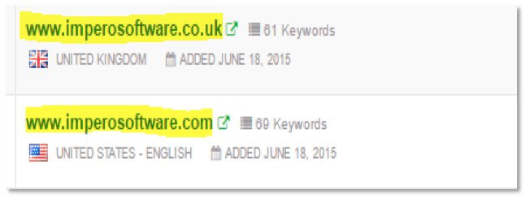

1. **International PPC**

For international PPC we have to consider changes in offering by locale, language, social components and innovation utilized among the different nations that we are focusing on. In any event, for an expert in PPC, bringing the main plunge into PPC for various nations can feel like a fresh out of the plastic new world. Make sure you take the time to review your campaign setup to cover your crucial language and messaging basics. Be aware of the ways that practices and goes through may change with your overall crowd. So it’s important to take in consideration the changing CPCs, sending visitors on desired pages, Quality scores and the average ad position.

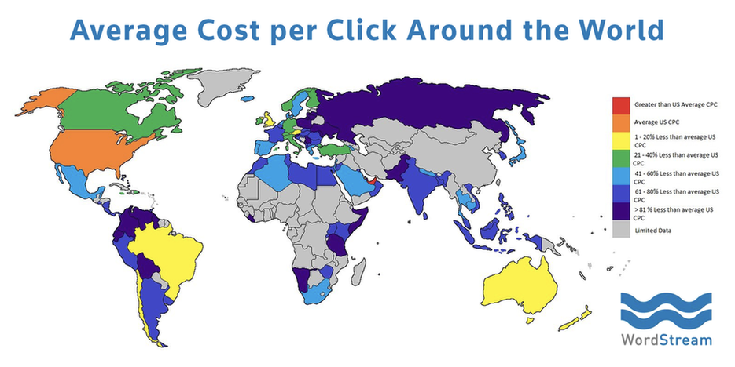

The average CPC drastically changes according to the region where you are looking for advertising. The cost for the paid advertising per clicks in the above image shows the data for US.

1. **International Social Media Marketing**

Social media plays a huge role in digital marketing. Today almost the whole world is on social media, we can have different platforms or different social media accounts for US and UK but we have to make sure that the account is always active so that people will start talking and engaging about the new firm. It also helps us to keep a track on the trends in social media. We can have different social media accounts for both the countries and post according to the festivals, languages spoken and the type of people in the country. We have to ensure that we post whatever conveys our brand message and portrays our brand image properly to which the people of that particular country can relate to. We need to appoint a social media manager for both the countries separately and make him understand what he can or cannot say or do on social media. This may take time but it is worth it as social media a great way to influence nowadays to this generation while conveying your brand values. Before all of this the important thing that we need to consider is which social media platform is most used in the country. In UK, 56% people are using Facebook, 42% Instagram, 40% Twitter and 37% Google+. While for US, 74% are using Facebook, 63% Snapchat, 60% Instagram, 46% Twitter. According to the above percentages we can manage our social media accounts for effectively utilizing our resources for social media marketing. It is necessary to regularly post relevant and eye catching content that the prospect customer wants to read and share.